Slide 1 | 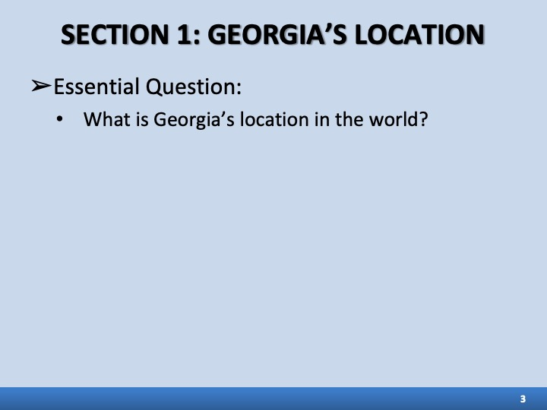 | ___________________________________  ___________________________________  ___________________________________  ___________________________________
Slide 2 | 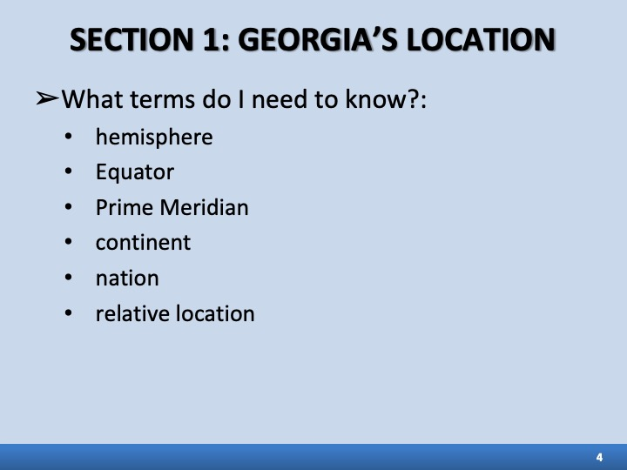 | ___________________________________  ___________________________________  ___________________________________  ___________________________________
Slide 3 | 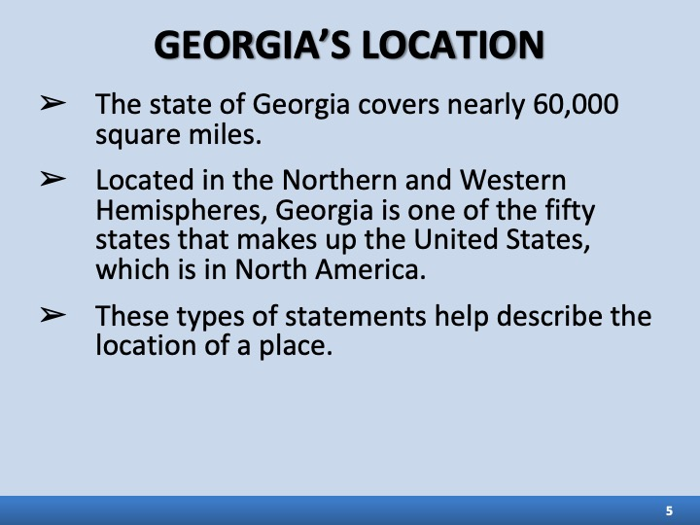 | ___________________________________  ___________________________________  ___________________________________  ___________________________________
Slide 4 | 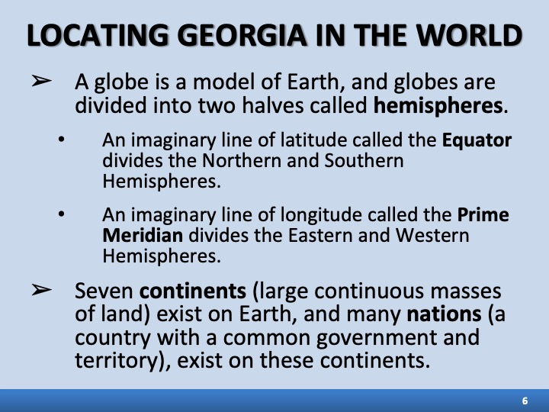 | ___________________________________  ___________________________________  ___________________________________  ___________________________________
Slide 5 | 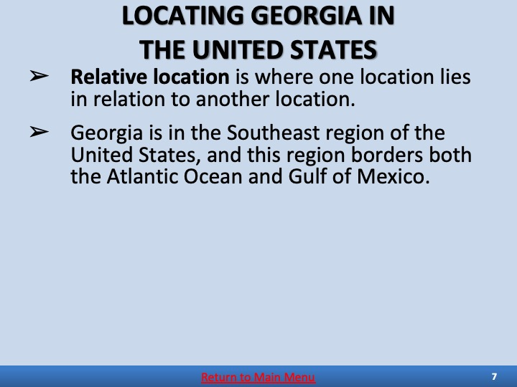 | ___________________________________  ___________________________________  ___________________________________  ___________________________________
Slide 6 | 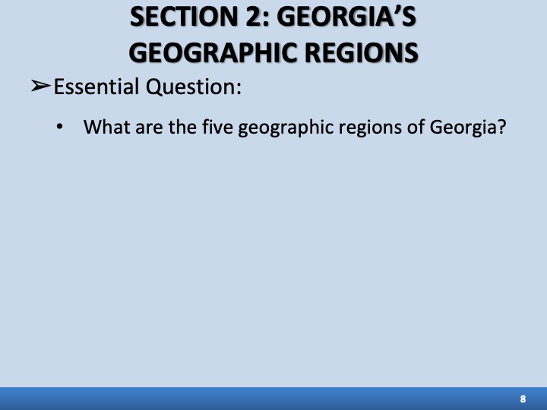 | ___________________________________  ___________________________________  ___________________________________  ___________________________________
Slide 7 | 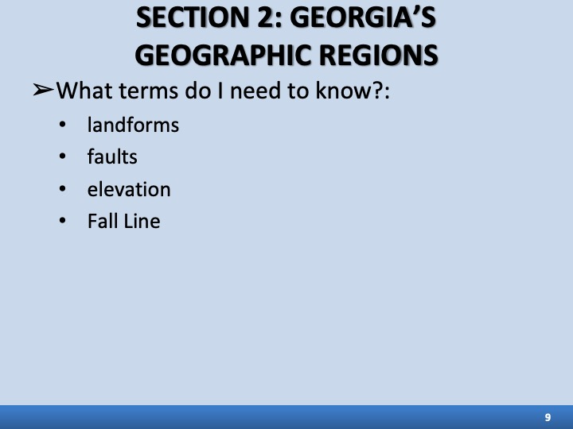 | ___________________________________  ___________________________________  ___________________________________  ___________________________________
Slide 8 | 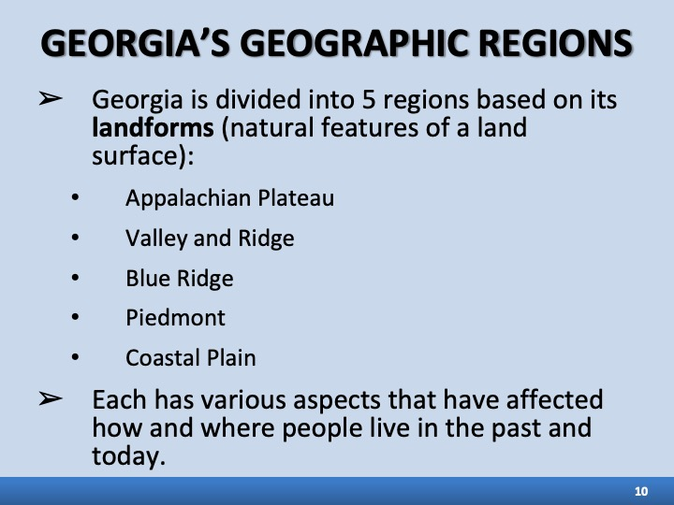 | ___________________________________  ___________________________________  ___________________________________  ___________________________________
Slide 9 | 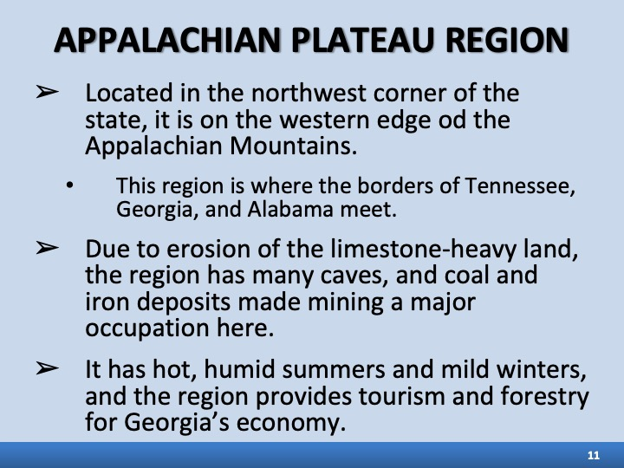 | ___________________________________  ___________________________________  ___________________________________  ___________________________________
Slide 10 | 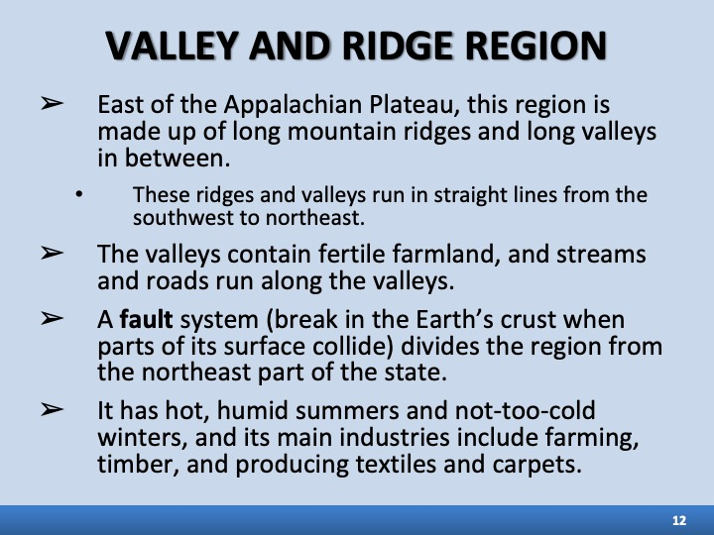 | ___________________________________  ___________________________________  ___________________________________  ___________________________________
Slide 11 | 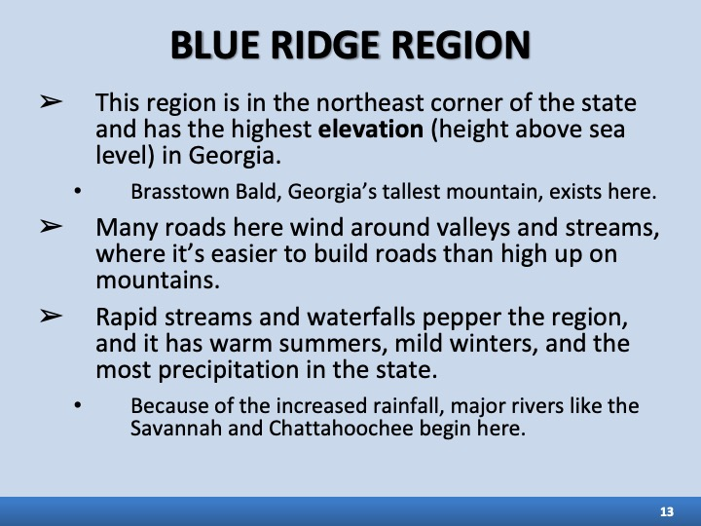 | ___________________________________  ___________________________________  ___________________________________  ___________________________________
Slide 12 | 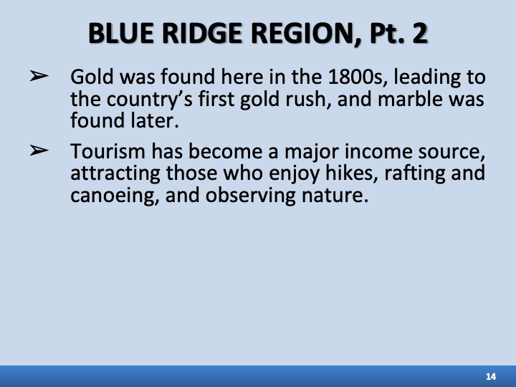 | ___________________________________  ___________________________________  ___________________________________  ___________________________________
Slide 13 | 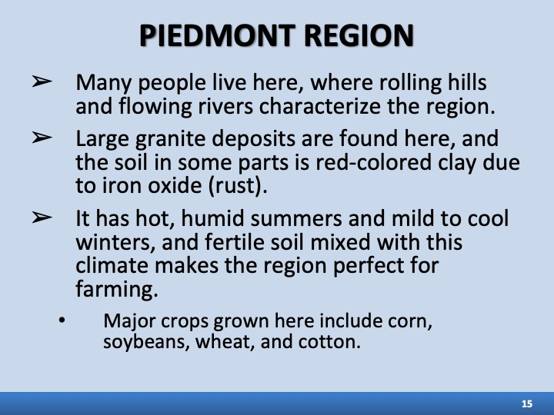 | ___________________________________  ___________________________________  ___________________________________  ___________________________________
Slide 14 | 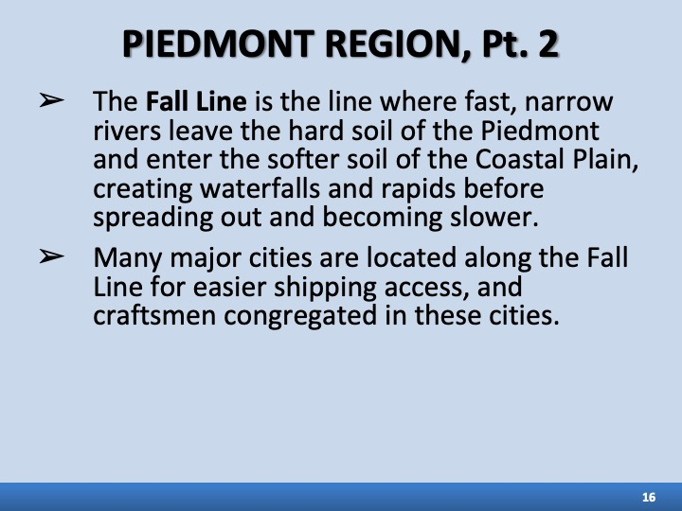 | ___________________________________  ___________________________________  ___________________________________  ___________________________________
Slide 15 | 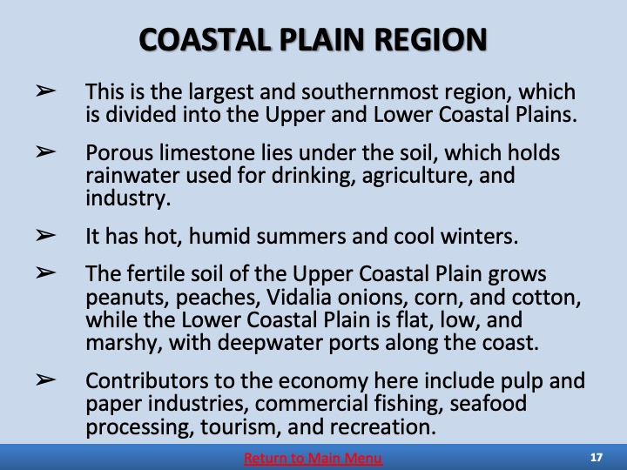 | ___________________________________  ___________________________________  ___________________________________  ___________________________________
Slide 16 | 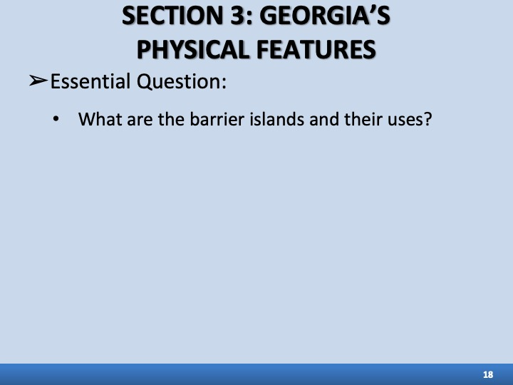 | ___________________________________  ___________________________________  ___________________________________  ___________________________________
Slide 17 | 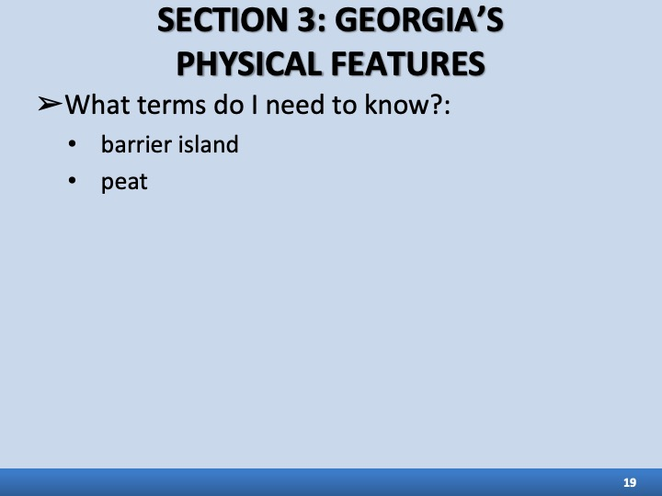 | ___________________________________  ___________________________________  ___________________________________  ___________________________________
Slide 18 | 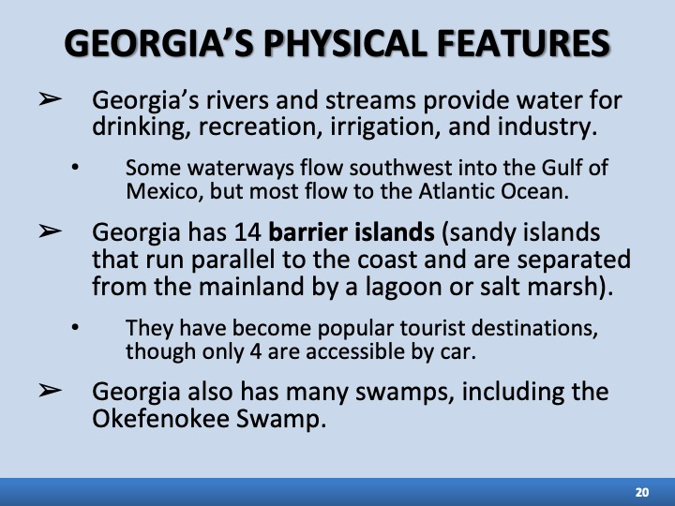 | ___________________________________  ___________________________________  ___________________________________  ___________________________________
Slide 19 | 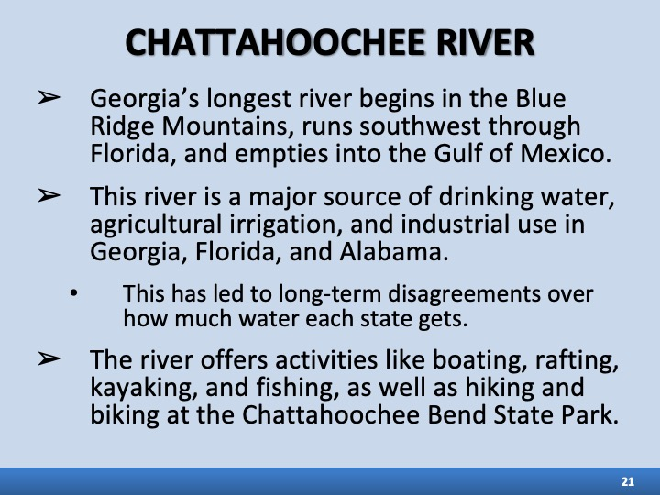 | ___________________________________  ___________________________________  ___________________________________  ___________________________________
Slide 20 | 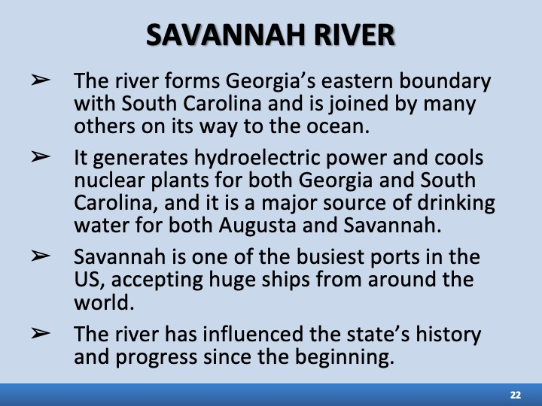 | ___________________________________  ___________________________________  ___________________________________  ___________________________________
Slide 21 | 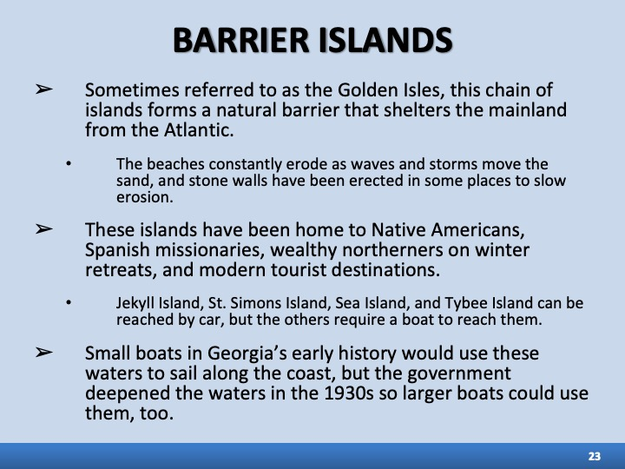 | ___________________________________  ___________________________________  ___________________________________  ___________________________________
Slide 22 | 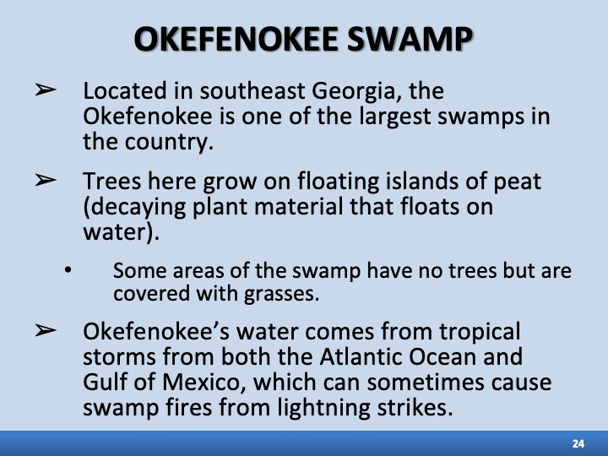 | ___________________________________  ___________________________________  ___________________________________  ___________________________________
Slide 23 |         

