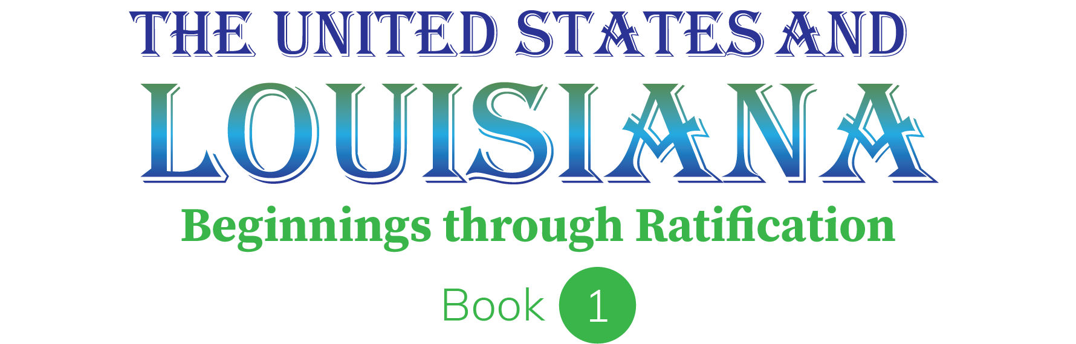
Internet Activities Teacher Guide and Answer Key

These easy-to-follow lessons require students to have Internet access. The structure of the lessons assumes that each lesson will be completed in a computer lab; however, students could work individually or in small groups at a single classroom computer or in a setting where they have access to their own devices.

Each lesson provides a connection to the textbook content. Students are challenged to use and extend their information processing, research, and map skills through these lessons.

We hope you and your students will find these lessons a welcome and useful extension of your instruction.

Before Each Lesson

- Locate the Internet Activity for the appropriate chapter on your Teacher Tech website.

- Open the Internet Activity link.

- Verify that links for the activity are still working. Since URLs change frequently, it may be necessary to provide a different link to your students than the one provided.

- Print the pages for the activity unless your students will be answering questions online using their device. In general, the lessons are organized so that one copy of the activity sheet is needed for each student. However, pairs of students could share activity sheets if they are working together.

During the Lesson

- Guide students to open the activity on their device or distribute a copy of the activity sheet to each student or pair of students, depending on your preference, as students are logging in to their student website.

- The Internet Activity link will open a form-fill PDF. This file contains the hyperlinks needed for the lesson. When the hyperlink is clicked, a Security Message may be displayed. Instruct students to click “Allow” to proceed.

- Show students how the questions on the webpage match the activity sheet. Then, model how to click the links and use the “Back” button, if necessary, in your Web browser to return to the activity page.

Website addresses (URLs) change frequently. It is therefore good practice to test the links used in each activity. In addition, it is good practice to test videos or special features of a website on the devices that your students will use because a school district’s devices may be configured to block certain types of files that are easily accessed outside of the school’s network. Work with your school or district technology team, as needed, to gain access to the web resources that you need.

The remainder of this booklet contains teacher notes and answer keys for each of the Internet activities.

Good luck and have fun!

Teacher Notes and Answer Keys

Chapter 10: The Road to Revolution

Summary:
Students will use a series of websites to review and learn more about the Road to the Revolution and specifically about propaganda and satire created during the conflicts between the British and colonists.

Duration: 45-90 minutes

Notes:

Extension readings: For students with the interest and capability, there are two additional readings that provide other examples of propaganda involved in the road to revolution.
  - This site shows and explains artifacts from protests in early America. https://www.amrevmuseum.org/protest-in-early-america-discovery-cart
  - This site focuses on the Boston Massacre engraving by Paul Revere and changing depictions of Crispus Attucks: https://www.amrevmuseum.org/boston-massacre-and-propaganda-changing-depictions-of-crispus-attucks
- Extension activity: Have a student explore the virtual Museum of the American Revolution. Students could create their own propaganda poster to support the colonial cause.

Answer Key:
Part 1
  - Answers will vary. Man with red coat, holding a teapot and another man have a rope around another man’s neck who is in feathers. It looks like they will be hanging him.
  - The teapot represents a story about a mob who forced a tax collector to drink so much tea that it threatened his life.
  - The tax collector may have been forced to drink tea because he was collecting money/taxes from the colonists. The colonists were angry about the tea tax.
  - Answers will vary. The Americans were portrayed as a low-status mob. The tax collectors were usually not hung, but the British propaganda portrays it that way.
  - Answers will vary. The colonial propaganda makes the crowd look respectable and that the British were solely at fault in the Boston Massacre.
Part 2
- 1775
- London
- Tea
- Continental Congress resolution in 1774
- Answers will vary. Faces made particularly unattractive. They are pouring tea into a hat. There is a small child being ignored. They are being influenced by a man.
- Given it is satire, the title is not meaning that the ladies were actually patriotic. The British would see this as going against the British government.

