Chapter 6: Federal Republic of Germany

Germany’s Acid Rain Problem

In this lesson, you will study three websites to learn more about the harmful effects of acid rain and what governments and individuals can do to combat this problem. After researching the problem and choosing the best solution, you will create an online flyer to convince your audience to take action.

Part 1: Research
Directions: Choose three of the following websites to help you learn more about the problem of acid rain in Germany. As you read, think about which solution you think would work best and how you could convince someone to help solve this problem.
- Acid Rain from U.S. EPA - http://bit.ly/acidrainepa
- Acid Rain video from Study.com - http://bit.ly/arvideo6
- Acid Rain article from Better Planet - https://bit.ly/acidrainbpe
- What Is Acid Rain? from Conserve Energy Future (scroll down to the SOLUTIONS TO ACID RAIN heading) - http://bit.ly/acidrainsolutions

Part 2: Determine a Solution
Directions: The German government has chosen your group to determine the best solution to the problem of acid rain. Based on your reading, create an online flyer to persuade a group to take action. Choose from one of the following scenarios:
1. Encourage German drivers to use less gasoline by driving fewer miles or opting for electric or hybrid vehicles.
2. Persuade German power plant owners to switch to nuclear energy and/or alternative sources like wind or solar power for their operations.
3. Persuade German lawmakers to pass a law requiring power plants to use environmentally friendly smokestacks that produce less pollution.
4. Encourage German citizens to cut down on their home electricity use, helping to lower fossil fuel consumption at power plants.
5. Wild card: Decide on a choice approved by your teacher.

Group Members ______________________________________ Choice Number ___________

Part 3: Create Your Flyer
Directions: Use Adobe Spark (or another online website chosen by your teacher) to create your flyer. Follow the directions below to get started. Be sure to use at least 3 images in your flyer.
1. Using a web browser, go to https://spark.adobe.com/login.
2. Follow your teacher’s directions about how to log in.
3. Click the Plus sign to create a new project. Choose “Page” for your type of project, or choose from one of the pre-created templates: Promote Something – Newsletter and Teach & Inspire – Presentation are good for beginners.
4. After adding a title and your name, click the Plus button to add another element. You can choose from photo (search under “Find Photos” on the right-hand pane of the screen), text, button (web link), or another element.

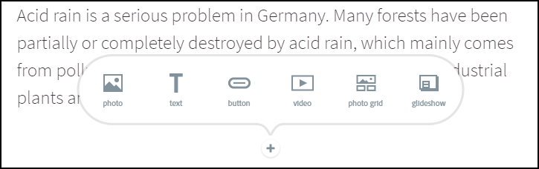

5. Be sure to add several elements to tell your audience about the effects of acid rain and to convince them of how they can help solve the problem of acid rain. You can also choose “Theme” to change the layout of your flyer.
6. When you are happy with your finished product, choose “Share” at the top of the page. Be sure to turn off the Author and Get noticed sliders and create your unlisted link.

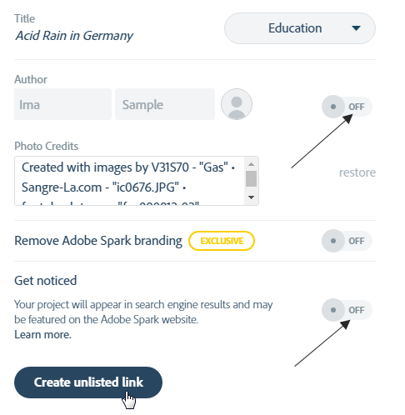
7. Share your finished link by following your teacher’s directions; you can copy/paste the link or embed code, send by email, or write the link here (it will start with https://spark.adobe.com).

Link: https:/spark.adobe.com/page/__________________

