Chapter 12: The Geography and History of Latin America

The Development of Latin America

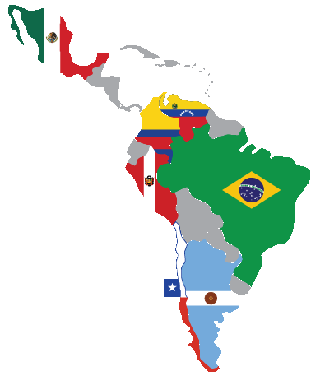
In this lesson, you will learn about Latin America through an online presentation with images, videos, and text. You will answer questions to show your knowledge of how slavery influenced the development of the Americas and how languages and religions from Spain and Portugal spread to Latin America.

Directions: Navigate to the online presentation, found at http://bit.ly/latinam6.
Watch the first 6 slides, then answer the questions below.
1. What kind of work did the first slaves do?
A. Domestic chores (housework)
B. Metal and woodwork
C. Farming
D. Child care
2. Where did most of the slaves come from? _________________________________________
3. What were two important crops grown in the Americas?
___________________________ _________________________________

Now, view slides 7-14, then answer the questions below.
4. What is the triangular trade? ___________________________________________________
___________________________________________________________________________
___________________________________________________________________________
5. What are 3 things that were shipped from the Americas to Europe?
_______________________ ______________________ ________________________
6. How did the spread of slavery and African culture influence the Americas?
___________________________________________________________________________
___________________________________________________________________________
7. Why are Spanish and Portuguese the most common languages spoken in Latin America?
___________________________________________________________________________
__________________________________________________________________________

View the rest of the presentation (slides 15-20), then answer the questions below.
8. How did the Spanish spread Christianity throughout their colonies? ____________________
___________________________________________________________________________
9. What is the most popular form of Christianity in Latin America today?
A. Protestantism
B. Roman Catholicism
C. Buddhism
D. Mormonism

Finished Early? Check out this World Religions Map from PBS (http://bit.ly/wrmap1), or any of the great tutorials and games on South and Central American countries (http://bit.ly/samcam2).

